
MARWADI EDUCATION FOUNDATION ’S GROUP OF INSTITUTIONS GAURIDAD CAMPUS, RAJKOT
DEPARTMENT OF INFORMATION AND COMMUNICATION TECHNOLOGY

BOTBUILD : MAKE YOUR OWN CHATBOT Date: 02-08-2025

Event Report


MARWADI EDUCATION FOUNDATION ’S GROUP OF INSTITUTIONS GAURIDAD CAMPUS, RAJKOT
DEPARTMENT OF INFORMATION AND COMMUNICATION TECHNOLOGY

The session began with an introduction to the DS Club, an initiative developed by students of the ICT Department under the guidance of Professor Nishith Kotak. The club is dedicated to exploring the vast fields of Data Science and
Data Visualization, with the goal of helping members understand how data can be analyzed to draw meaningful conclusions and make informed decisions.

- What are Chatbots ?
A chatbot is a computer program designed to simulate human conversation through text or voice interactions. It can answer questions, provide information, perform tasks, or guide users — often without the need for direct human assistance. Chatbots use rules, AI, or both to understand user input and respond appropriately. They are widely used in customer service, education, e-commerce, healthcare, and more
- TechStack Used

  - Google Colab
Colab notebooks allow you to combine executable code and rich text in a single document, along with images, HTML, LaTeX and more, also it has many libraries already install. So we are using google colab rather than vs code.


MARWADI EDUCATION FOUNDATION ’S GROUP OF INSTITUTIONS GAURIDAD CAMPUS, RAJKOT
DEPARTMENT OF INFORMATION AND COMMUNICATION TECHNOLOGY

  - Visual Studio Code:
VS Code is a free, lightweight, and powerful code editor developed by Microsoft, used for writing, editing, and debugging code in multiple programming languages. It offers features like syntax highlighting, debugging tools, integrated terminal, Git integration, and support for extensions, making it a popular choice among developers for efficient and productive coding.

The process of building Rule Based Chatbot
    - Set up your environment : Visit Google Colab and create a new notebook.
Lets dig on the rules functions and dictionaries used to write a Python code to create a simple chatbot for a fictional cake shop called "The Happy Cake Shop.

rules Dictionary:
  - This dictionary stores predefined responses for the chatbot.
  - The keys are keywords or phrases the user might type (e.g., "hello", "menu", "chocolate cake").
  - The values are the corresponding responses the chatbot will provide.

cakeshop() Function:
  - This function contains the main logic for the chatbot.
  - It starts by printing a welcome message: "welcome to Cakeshop".
  - It then enters an infinite while True: loop to continuously listen for user input.

Inside the Loop:


MARWADI EDUCATION FOUNDATION ’S GROUP OF INSTITUTIONS GAURIDAD CAMPUS, RAJKOT
DEPARTMENT OF INFORMATION AND COMMUNICATION TECHNOLOGY

  - user_input = input("you:").lower(): This line prompts the user for input with "you:", takes what they type, and converts it to lowercase to make it easier to match with the keywords in the rules dictionary.
  - responce_found = False: A boolean variable is initialized to False. This will be used to track whether a response has been found for the user's input.
  - for key in rules:: The code iterates through each key in the rules dictionary.
  - if key in user_input:: It checks if the current key (keyword) is present in the user_input.
  - print(f">Bot : {rules[key]}"): If a keyword is found, it prints the corresponding response from the rules dictionary.
  - responce_found = True: The responce_found flag is set to True since a response has been given.
  - Redundant if statements: After the loop, there are a series
of if statements that check for the same keywords again (e.g., "bye",
"custom", "chocolate cake"). This is redundant because the loop already handles these cases. This is why you see duplicate output. For example, if you type "custom", you will see the response from the rules dictionary and also the response from the separate if "custom" in user_input: block.
  - if responce_found == False:: If the loop finishes and no matching keyword was found, this condition becomes true, and the chatbot prints "i didn't understand this".

cakeshop() Call:
  - Finally, the cakeshop() function is called to start the chatbot.

In summary, the code creates a basic, rule-based chatbot. It's a good starting point, but the redundant if statements after the loop should be removed to avoid duplicate responses and make the code cleaner.


MARWADI EDUCATION FOUNDATION ’S GROUP OF INSTITUTIONS GAURIDAD CAMPUS, RAJKOT
DEPARTMENT OF INFORMATION AND COMMUNICATION TECHNOLOGY

An NLP (Natural Language Processing) chatbot is an AI-powered chatbot that can understand, interpret, and respond to human language in a natural way. By using techniques from linguistics, machine learning, and artificial intelligence, it can process user queries beyond fixed keywords, handle complex conversations, and provide more accurate and context-aware responses, making interactions feel more human-like.
Step by Step process:
- Set Up Visual Studio Code : Create a new text file.
- Install the necessary libraries:
  - streamlit
  - torch
  - transformers
    - Import Required Libraries:
For core code of chatbot: torch and from transformers import (
AutoTokenizer, AutoModelForCausalLM, BlenderbotTokenizer, BlenderbotForConditionalGeneration, GPT2LMHeadModel,
GPT2Tokenizer, Pipeline.


MARWADI EDUCATION FOUNDATION ’S GROUP OF INSTITUTIONS GAURIDAD CAMPUS, RAJKOT
DEPARTMENT OF INFORMATION AND COMMUNICATION TECHNOLOGY

    - we can also include two or more GPTs to make user choice flexible.
    - We also use Model Loading Methods (load_*)
      - The class has several methods for loading different chatbot models:
        - load_gpt2_conversational(): Loads "DialoGPT," a version of GPT- 2 that's been specifically fine-tuned for conversations.
        - load_blenderbot_small(): Loads Facebook's "BlenderBot Small," another popular conversational AI.
        - load_conversational_pipeline(): Instead of loading a model and tokenizer separately, this uses Hugging Face's pipeline for a more streamlined setup.
        - load_gpt2_chat(): Loads the standard GPT-2 model, which can also be used for chat.

    - For generating responses accordingly we use

Response Generation Methods (generate_*_response)
      - For each model type, there's a corresponding method to generate a response:
        - generate_dialogo_response()
        - generate_blenderbot_response()
        - generate_pipeline_response()
        - generate_gpt2_response()

Helper Methods
      - is_model_loaded(): A simple check to see if a model has been loaded.
      - get_model_info(): Provides a user-friendly name for the currently loaded model.
      - This makes the core code of chatbot.


MARWADI EDUCATION FOUNDATION ’S GROUP OF INSTITUTIONS GAURIDAD CAMPUS, RAJKOT
DEPARTMENT OF INFORMATION AND COMMUNICATION TECHNOLOGY

Interface Structure of the chatbot Code details:

Page Configuration:
  - It sets up the title, icon, and layout for the web page.

Main Function:
  - Title and Subheader: Displays the main title and a brief description of the application.

Sidebar:
    - Creates a sidebar for model selection.
    - Allows the user to choose from a list of pre-defined AI models: "DialoGPT", "BlenderBot Small", "Conversational Pipeline", and "GPT-2 Chat".
    - Includes a button to clear the chat history.

Chatbot Initialization:
    - It checks if a chatbot object exists in the session state. If not, it creates a new EnhancedChatbot instance.

Model Loading:
    - It loads the selected AI model based on the user's choice from the sidebar. It displays a loading spinner while the model is being loaded.
    - If the model loads successfully, it shows a success message; otherwise, it displays an error.

Chat History:
    - It initializes the chat history with a welcome message from the assistant.

Model Information:


MARWADI EDUCATION FOUNDATION ’S GROUP OF INSTITUTIONS GAURIDAD CAMPUS, RAJKOT
DEPARTMENT OF INFORMATION AND COMMUNICATION TECHNOLOGY

    - It displays the information about the currently loaded model.

Displaying Chat Messages:
    - It iterates through the chat history and displays each message in the chat interface.

Chat Input:
    - It provides a text input field for the user to type their messages.
    - When the user sends a message, it's added to the chat history, and the AI generates a response.
    - The AI's response is then displayed and added to the chat history.

Quick Start Examples:
    - It provides four example buttons with pre-defined prompts.
    - When a user clicks an example button, the corresponding prompt is sent to the chatbot, and the response is displayed.

Running the Application:
  - The if name == " main ": block ensures that the main() function is called only when the script is executed directly.

Serial.no | Full Name | Department Name | Semester
1 | Zeel Patel | ICT Diploma | 5
2 | KACHA TUSHAR PANKAJBHAI | Faculty of science | 1
3 | Zohair sadikot | CSE AI AND ML | 3
4 | Gadhia Pulind | Cse(ai -ml) | 3
5 | Isha Kakadiya | Msc Data Science | 1
6 | Maulik Parmar | MBA (BA) | 1
7 | Om Nagar | CSE-AI&ML | 3
8 | Aditya Raj | ICT | 5
9 | Pathan Ruhaan | ICT | 3
10 | Ashutosh Kumar Singh | ICT | 5
11 | Kaushik Bipinbhai Ajani | M.sc Data science | 1
12 | Rashida Gandhi | ICT | 5


MARWADI EDUCATION FOUNDATION ’S GROUP OF INSTITUTIONS GAURIDAD CAMPUS, RAJKOT
DEPARTMENT OF INFORMATION AND COMMUNICATION TECHNOLOGY

13 | Kiran | CSE-AIML | 3
14 | R.Mohan Krishna | ICT | 3
15 | Manogna | CSE_AIML | 3
16 | Shashidhar Y R | ICT | 3
17 | Hardev dangar | i.c.t | 1
18 | Arindam Poorey | Ict Diploma | 5
19 | Rajdeep Jadeja | ICT ( Information and Communication  Technology | 3
20 | Mihir Mithani | ICT | 5
21 | Muskan Lalani | ICT | 1
22 | Mohit Parekh | ICT | 3
23 | Satyajeetsinh Chudasama | ICT | 3
24 | Yaswanth Melki Bolli | ICT | 3
25 | HARSHAL BHATT | ICT | 3
26 | Nitya choksi | Ict diplom | 1
27 | Thakkar Mandeep K | Computer science and engineering (AI and ML) | 3
28 | DHAVAL CHAVDA | ICT | 3
29 | Prince Gupta | Information and communication technology | 1
30 | Vedant Gondaliya | ICT | 1
31 | Singh ankit maheshkumar | CE-AI | 5
32 | bagthariya vedant dipakbhai | ICT | 1
33 | VALERU YASHWANTH | ICT | 3
34 | Rudransh Bhatt | CE-AI | 5
35 | Himanshu Singh | BTech Information Technology | 5
36 | PRANAV KETANKUMAR  TARPADA | ICT-Diploma | 5
37 | Daksh gauswami | Ict | 1
38 | Manav Chotai | B.Tech (ICT) | 3
39 | Jash Jani | ICT-Diploma | 3
40 | Ratan Thakar | 1A | 1
41 | Akshat Pankaj Shah | Ict | 3
42 | Sanghani utsav | CSE AI & ML | 3
43 | Samarth Dudakiya | ICT | 3
44 | Meet Jayvantbhai Dedania | ICT | 1
45 | Drashti Parecha | FOCA | 1
46 | Mansi Sarapadadiya | Foca | 1
47 | T.Balavardhansai | ICT | 3
48 | Rudra Ansuman Baldania | ICT | 5
49 | K.shrujith | Ict | 1
50 | Vishvesh Dave | ICT | 1
51 | AvanishShiyal | ICT | 1
52 | Mit chodvadiya | Btech - ict | 3
53 | Hit | ICT | 1


MARWADI EDUCATION FOUNDATION ’S GROUP OF INSTITUTIONS GAURIDAD CAMPUS, RAJKOT
DEPARTMENT OF INFORMATION AND COMMUNICATION TECHNOLOGY

54 | Parmar darshit | ICT DIPLOMA | 1
55 | Jaimeen parmar | ICT | 1
56 | Harsh Jadav | ICT Diploma | 1
57 | Kenil Parekh | Btech - ict | 3
58 | Charan Boddu | ICT | 1
59 | Saloni Ramavat | ICT | 3
60 | Avani Champakbhai Kavathiya | Information and communication technology | 3
61 | Ira Bhogayata | ICT | 3
62 | Siddhartha.Rattina | ICT | 3
63 | Slock Ahuja | ICT | 3
64 | Shivam Singh | Computer engineering | 3
65 | Shreya Nariya | Foca | 1
66 | Nilay Narendrabhai Dhruv | ICT-DIPLOMA | 5
67 | Bhavini Joshi | CSE-AI | 3
68 | Aman Kumar | Computer Engineering | 3
69 | I Yugandhar | ICT-DIPLOMA | 1
70 | Kishan patil | Diploma-ICT | 1
71 | Chirrogna Aishwarya | Diploma ict | 1
72 | Vidhi Ranpura | FOCA | 1
73 | bhargav siddhpura | ict | 1
74 | Arnol nakum | ICT DIPLOMA | 1
75 | Nakum dhaval | Ict | 1
76 | Aashray Rathod | ICT | 1
77 | Nalla Lakshmi sanjana | ICT | 1
78 | Hardeel ashara | i.c.t | 1
79 | Heer Mehta | ICT | 3
80 | Rishi Sampat | ICT | 3
81 | Vrushank Ramani | ICT | 3
82 | Rajdeep singh parmar | ICT | 1
83 | Shreya B M | ICT | 1



PHOTOS:
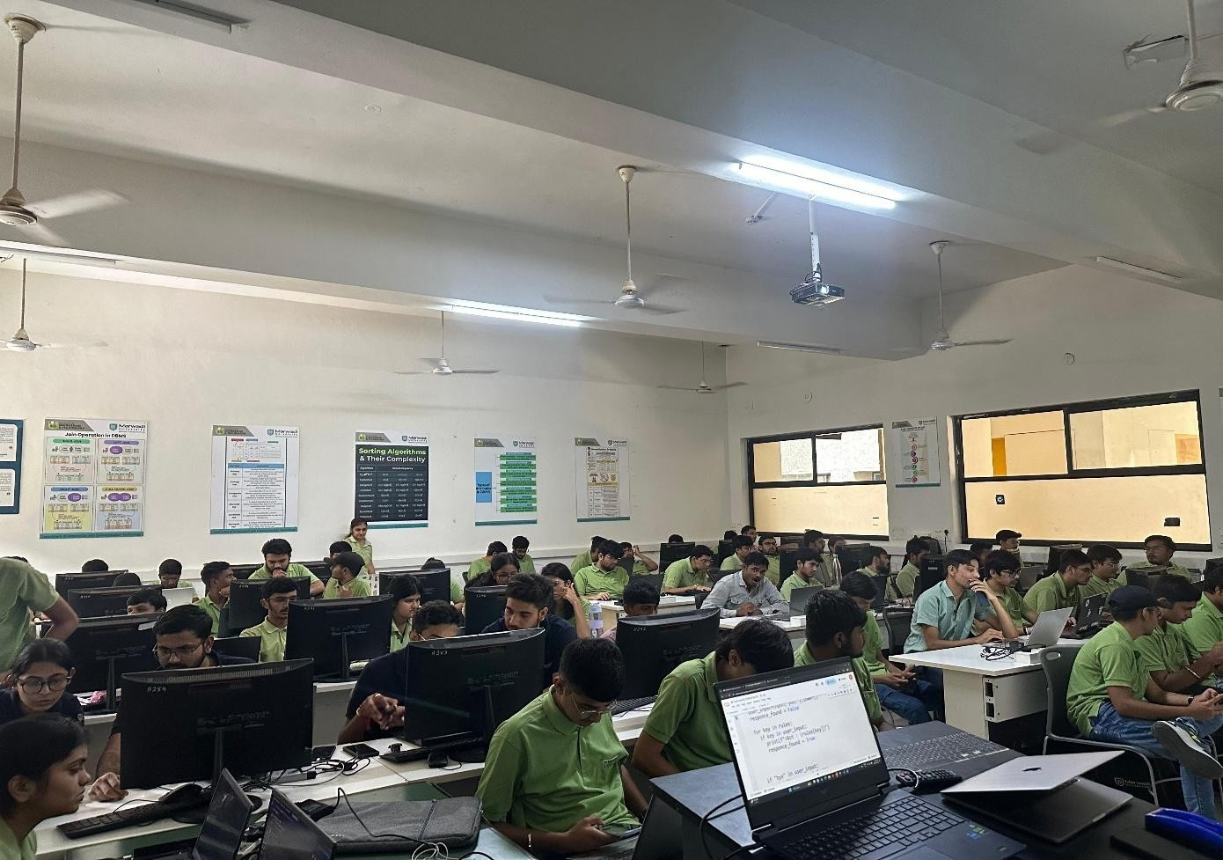
MARWADI EDUCATION FOUNDATION ’S GROUP OF INSTITUTIONS GAURIDAD CAMPUS, RAJKOT
DEPARTMENT OF INFORMATION AND COMMUNICATION TECHNOLOGY


MARWADI EDUCATION FOUNDATION ’S GROUP OF INSTITUTIONS GAURIDAD CAMPUS, RAJKOT
DEPARTMENT OF INFORMATION AND COMMUNICATION TECHNOLOGY

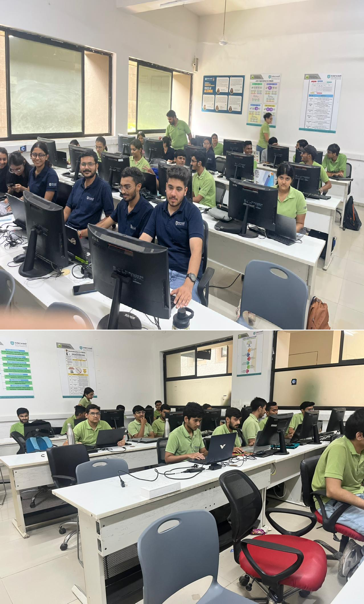


MARWADI EDUCATION FOUNDATION ’S GROUP OF INSTITUTIONS GAURIDAD CAMPUS, RAJKOT
DEPARTMENT OF INFORMATION AND COMMUNICATION TECHNOLOGY

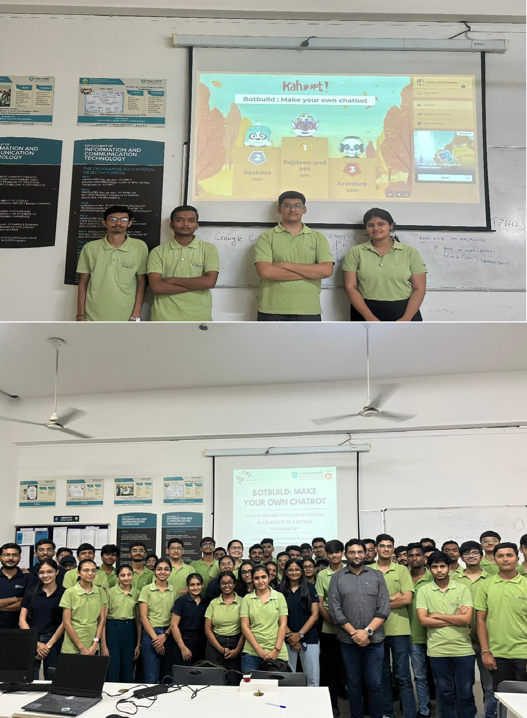


MARWADI EDUCATION FOUNDATION ’S GROUP OF INSTITUTIONS GAURIDAD CAMPUS, RAJKOT
DEPARTMENT OF INFORMATION AND COMMUNICATION TECHNOLOGY

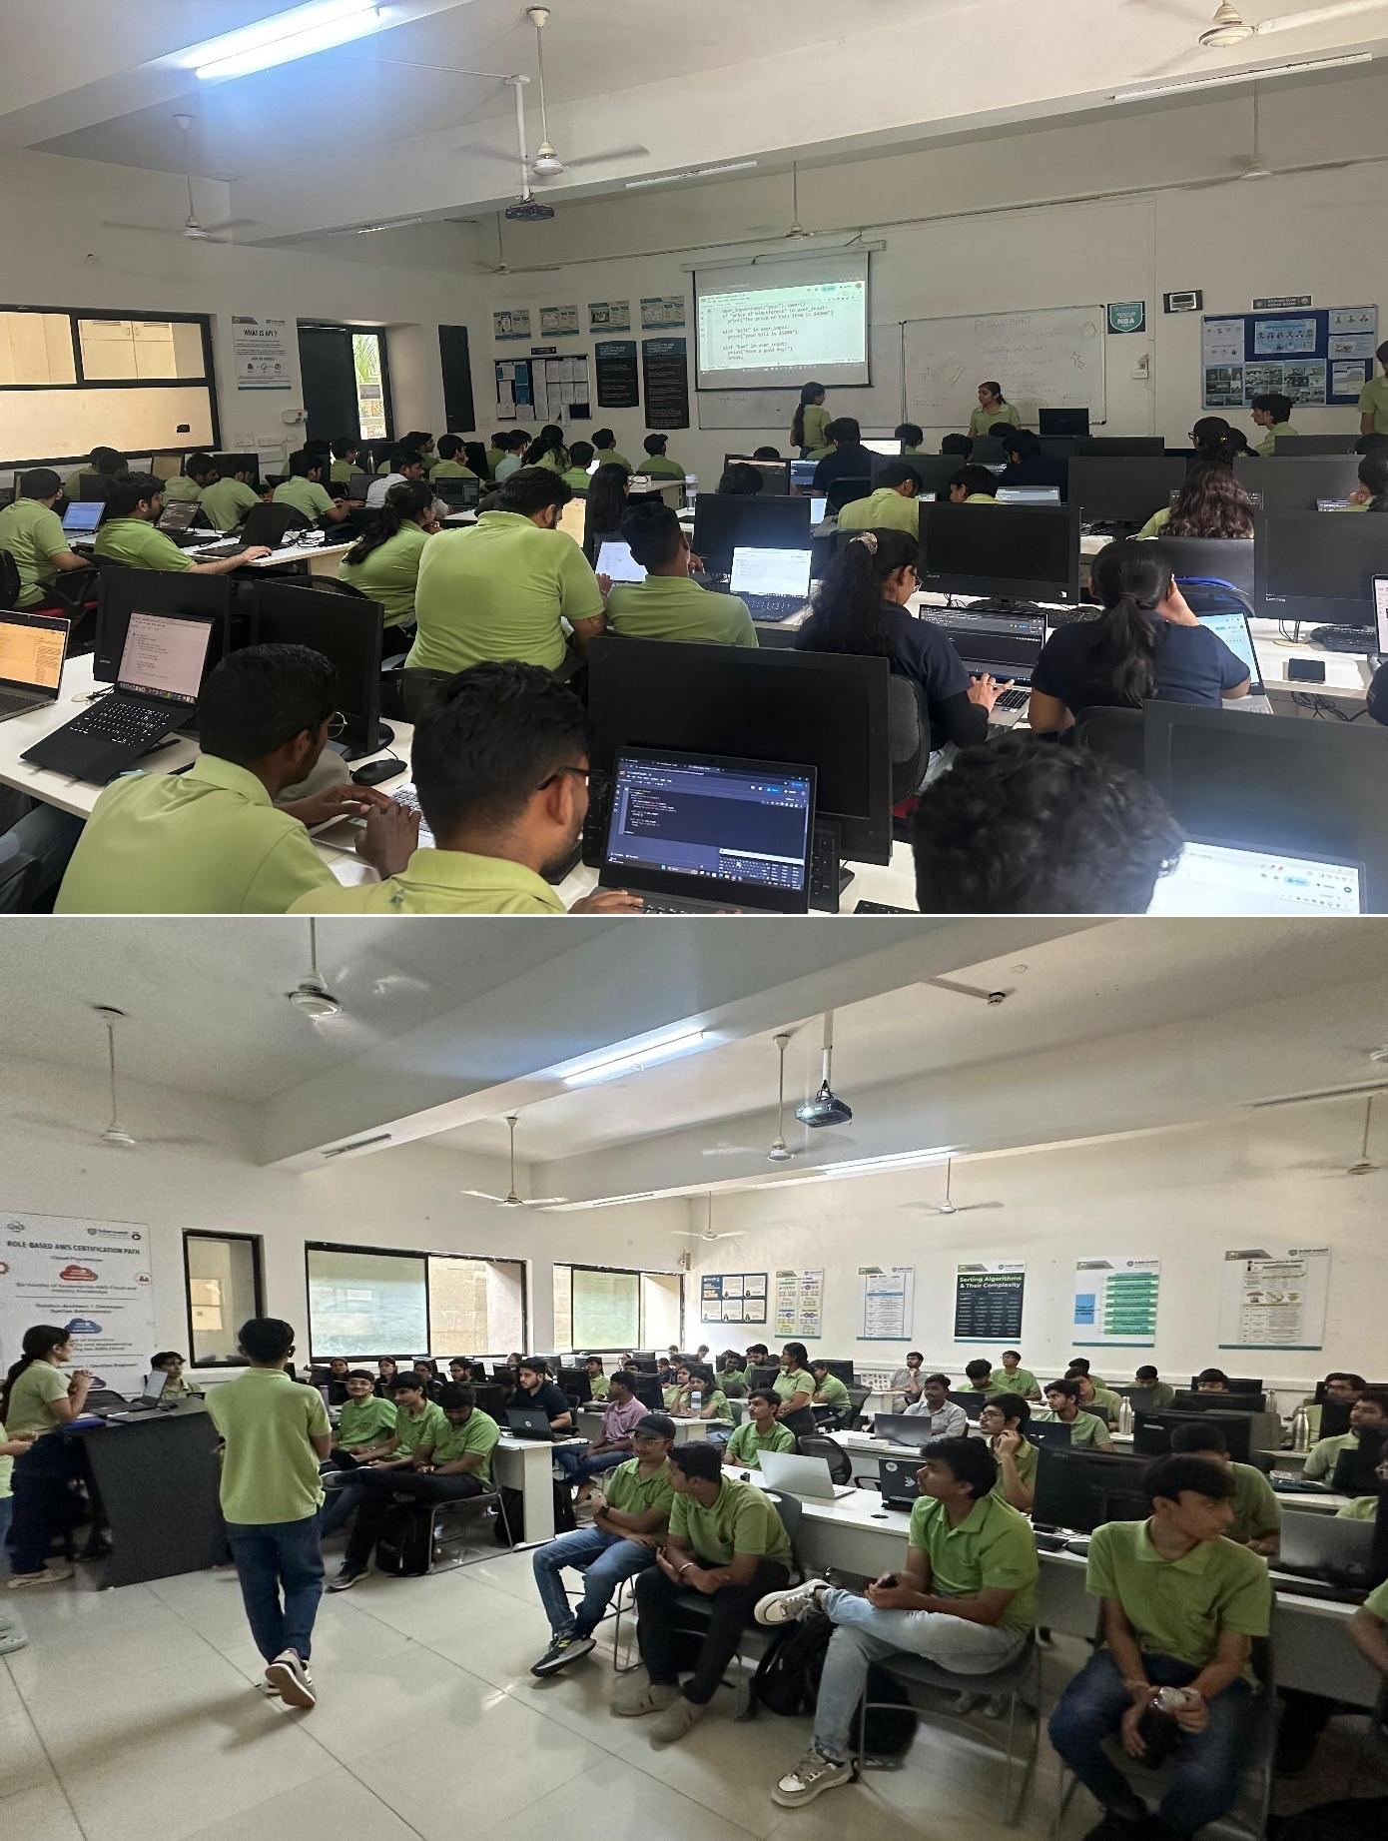


MARWADI EDUCATION FOUNDATION ’S GROUP OF INSTITUTIONS GAURIDAD CAMPUS, RAJKOT
DEPARTMENT OF INFORMATION AND COMMUNICATION TECHNOLOGY

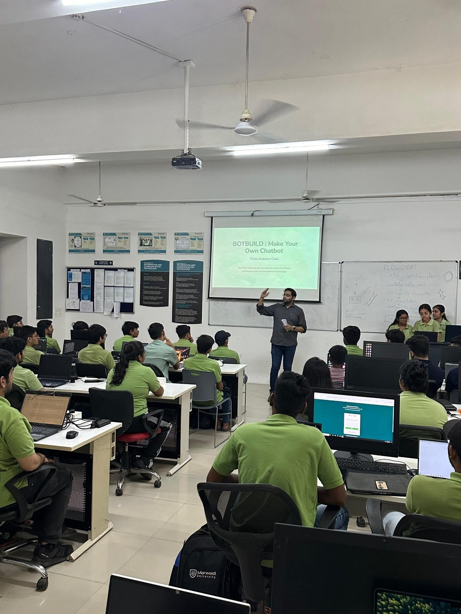


MARWADI EDUCATION FOUNDATION ’S GROUP OF INSTITUTIONS GAURIDAD CAMPUS, RAJKOT
DEPARTMENT OF INFORMATION AND COMMUNICATION TECHNOLOGY

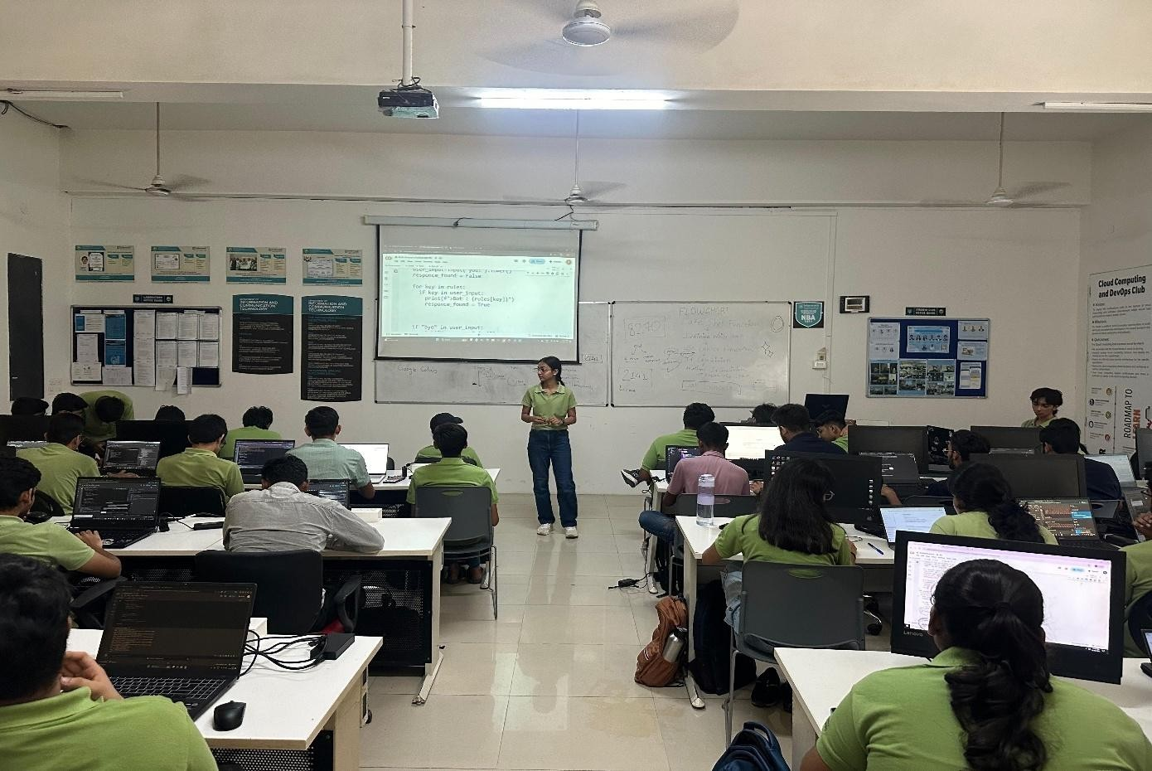

Committee members involved:
Introduction : Dhyana Kothari , Hitarthi Pansuriya Rule based chatbot : Rudra Miyani
NLP Based chatbot : Fenil Vadher

General Management and Participant assisting: Priyanshi Mandani and Dhruvi Bhalodiya

